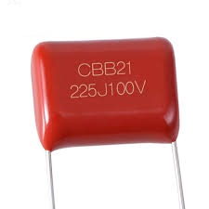
CBB21 – 225J / 100V Polyester Capacitor
CBB21 ek non-polar capacitor hota hai jo noise filtering, coupling aur signal smoothing ke liye use hota hai.
Ye AC aur DC dono me kaam karta hai.
Use Case
• SMPS feedback section
• Audio amplifier coupling
• Noise filter stage
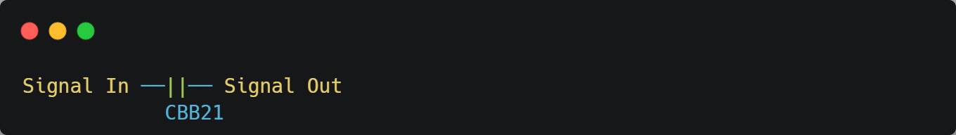
Ye DC block karta hai, AC signal pass karta hai.
👉 One Line yaad rakho:
CBB21 capacitor signal ko smooth karta hai aur noise ko filter karta hai – bina polarity tension ke.

Non-polar capacitor
Non-polar capacitor ka matlab hota hai – isme + aur – terminal fix nahi hota.
Tum ise kisi bhi direction me connect kar sakte ho.
Non-Polar Capacitor = aisa capacitor jisme polarity nahi hoti.

👉 One Line yaad rakho:
Non-polar capacitor wo hota hai jise ulta-seedha lagao, koi problem nahi hoti.

